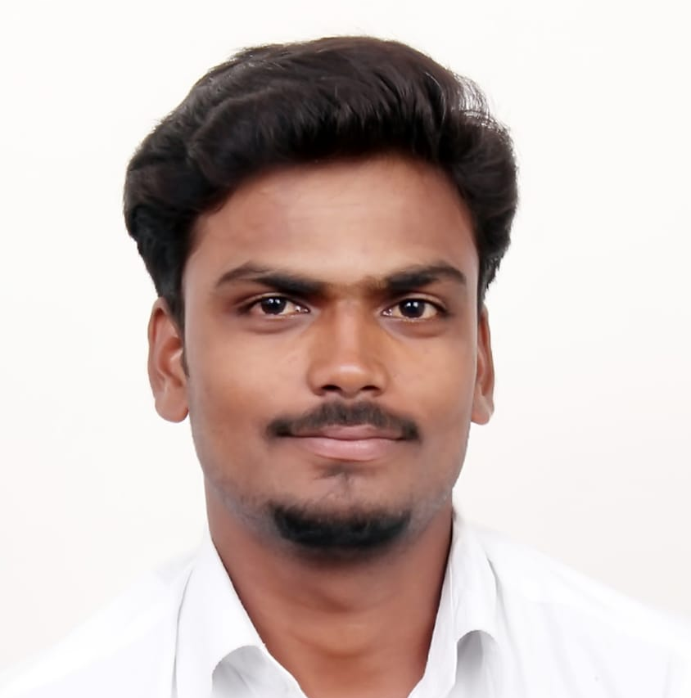
VEERASELVAN VANNIYARAJAN
B.E. –MECHANICAL ENGINEER
Contact No: +919597637040 Email: rajanveeraselvan@gmail.com

OBJECTIVE:
A professionally qualified Mechanical Engineer with hands on experience in Documentation, Estimation, Maintenance & operation. And seeking a position with a reputed organization where my education and experience will have valuable application. I assure that I will be a good valuable person for implement the system & process of the organization.
CORE COMPETENCE AREA:
- Power plant familiarization.
- Heavy equipment handling.
SNAP SHOT:
A competent professional with a Bachelor degree in mechanical engineering with having 3 year experience in Mechanical maintenance. Presently associated with CREW (P) LTD in RAJ WEST POWER LIMITED (JSW) (8X135MW) at Rajasthan as a Maintenance Engineer. I have good knowledge in MIS & SAP. A keen learner with ability to work under pressure and meet deadlines. Possess strong communication and inter-personal skills.
MAIN JOBS DONE AND RESPONSIBILITIES:
- Work permit management to protect against undesired incidents & ensure the permits for Technicians.
- Equipment / Area Ownership, Identified Technical Problem & Managing operation and Maintenance of Conveyor Belting System, Vibratory Screens, Crushers etc. With a target to improve MTBF and reduce MTTR.
- Daily Analysis of delays and take necessary actions to upkeep performance of all KPI of the section.
- Coordinating with all departments for day-to-day problem and job planning accordingly.
- Planning, coordinating of preventive and breakdown activities for achieving high plant availability to meet bunkering & production target.
- Documentation & Spare Management Knowledge. Manage history of data and its analysis by using MS-Excel & MIS software.
- Equipment health monitoring which involves vibration checks, Lubrication, sealing, temperature checks & Preventive maintenance. Prepare RCA for the related Breakdowns.
- Equipment repairs and overhaul scheduling, Inventory management and optimization, Outage/shutdown scheduling and planning, new equipment Capex planning and scheduling.
- Leading a team of technicians, skilled & unskilled workers for plant maintenance and up gradation.
- Conduct tool box meeting, departmental meeting, SMP, SWP & OJT on regular basis.
- Monthly planning for spare & consumable materials to meet reliability of equipment’s.
- Exposure in Erection, commissioning and installation of new equipment, O&M projects

EDUCATIONAL QUALIFICATION:
B.E (MECHANICAL ENGINEERING): 2015
CGPA 6.4 at CARE GROUP OF INSTITUTION (Anna University), Trichy.
LANGUAGES KNOWN:
- Tamil (Read, Write & Speak)
- Hindi (Speak)
- English (Read, Write & Speak)
P.T.O

EQUIPMENT AND MACHINERY HANDLED:
- Maintenance of Stacker/ Re-claimer (Stacking-1200 TPH & Reclaiming-800TPH), Reversible swinging hammer (Crusher 720 TPH), Flap gate, Rail clamping equipment, flip flow screen, Vibro-feeders, travelling equipment like shuttle feeders, travelling tipper trolley, RPG & Rod gate.
- Maintenance of material handling Equipment (Conveyor Belt) and all types of scrapper.
- Maintenance of Ball mill, Jack pump LUB system, DE, DSS, RAL, screw conveyor, FLS & GSS.
- Maintaining sub-equipment’s like pulleys, Plummer blocks, SDFC Fluid couplings, Gear coupling, pin bush coupling, scoop coupling, Gear box, Actuators, Valves (Deluge, Dome & etc.) & Pump (Gear, multi stage, centrifugal & mono block).
SOFTWARE SKILLS:
- SAP PM-WCM (ECC Production)
- MIS (Management Intelligent Software)
- DCS Operations
- Also exposure in AutoCAD & Pro-E.
- Microsoft office - word, Excel, Power point & OS – Windows 7, 8.
EXTRA CURRICULAM ACTIVITIES:
- Participated in state level Throw ball Tournament during (2008 & 2010).
SELF ASSESSMENT:
- Work involving dedication with team members, Good behaviour with colleagues and thinking about team work, Taking ownership about to reduce the idle man-hour.
- Complete the planned job with in the given TAT, Involving in System and Process
- Good Team Worker and Innovation with quick willingness to learn.
- Ability to adapt to new environment.
PERSONAL INFORMATION:

- Father’s Name : VANNIYARAJAN
- Date of Birth : 01-06-1992
- Gender : Male
- Religion : Hindu
- Nationality : Indian
- Marital Status : Single
Passport details:

Passport number : N1185746

Valid from : 09-07-2015
Valid to : 08-07-2025
Permanent Address:
798, Main Road. Kombadikuppam, Uthangal (Post), Vridhachalam (Tk), Cuddalore, TN, India Pin: 607804

DECLARATION:
I hereby declare that the particulars furnished above are true to the best of my knowledge.
[VEERASELVAN V]
Date :
Place :
Yours Sincerely,

